CENTRAL COLLEGE KAWEMPE

END OF YEAR ASSESSMENT EXAMS

S2 physics

Answer all questions

1 a)Define moment of a force and state it's SI unit

B)state the principle of moments

1. Jane and Peter sit on a uniform bar of wood of length 6m.Jane has a weight of 400N and she sits a distance 2m from the pivot, Peter sits a distance 1.5m from the same pivot. If the pivot is placed in the middle of bar of wood calculate Peter's weight
2. You have been given the following apparatus

Meter rule, two masses of 100g and 200g,knife edge, two threads, and a rectangular block of wood. Describe simple laboratory experiment to verify the principle of moments

2 a)Temperature and heat normally confuse people, as an S2 physics student,differentiate between temperature and heat

1. Water is not used in thermometers as a thermometric liquid

give the reasons why water is not used in thermometers

1. Give reasons why most thermometers contain mercury as a thermometric liquid but not alcohol

3 While seated in your classroom your friends wondered why the ventilators are always put at the top of the windows,they started arguing about this issue and decided to bet on the issue

1. Which method of heat transfer are ventilators an application

4 I) You are provided with the following machines; pair of scissors, wheelbarrow, seesaw and nut cracker

1. Group the above listed machines according to

First class levers

Second class levers

Third class levers

5 When a stone falls from a height of 2m and it hits John's feet ,he feels more pain than when the stone falls from a height of 1.2m

1. Explain this situation
2. If the stone has a mass of 5kg calculate the kinetic energy with which the stone hits John's feet

At a height of 2m

At height of 1.2m

6 The figure below shows a tank of water in form of acuboid , when it rains, the tank gets filled to full capacity with water of approximate weight of 1200N

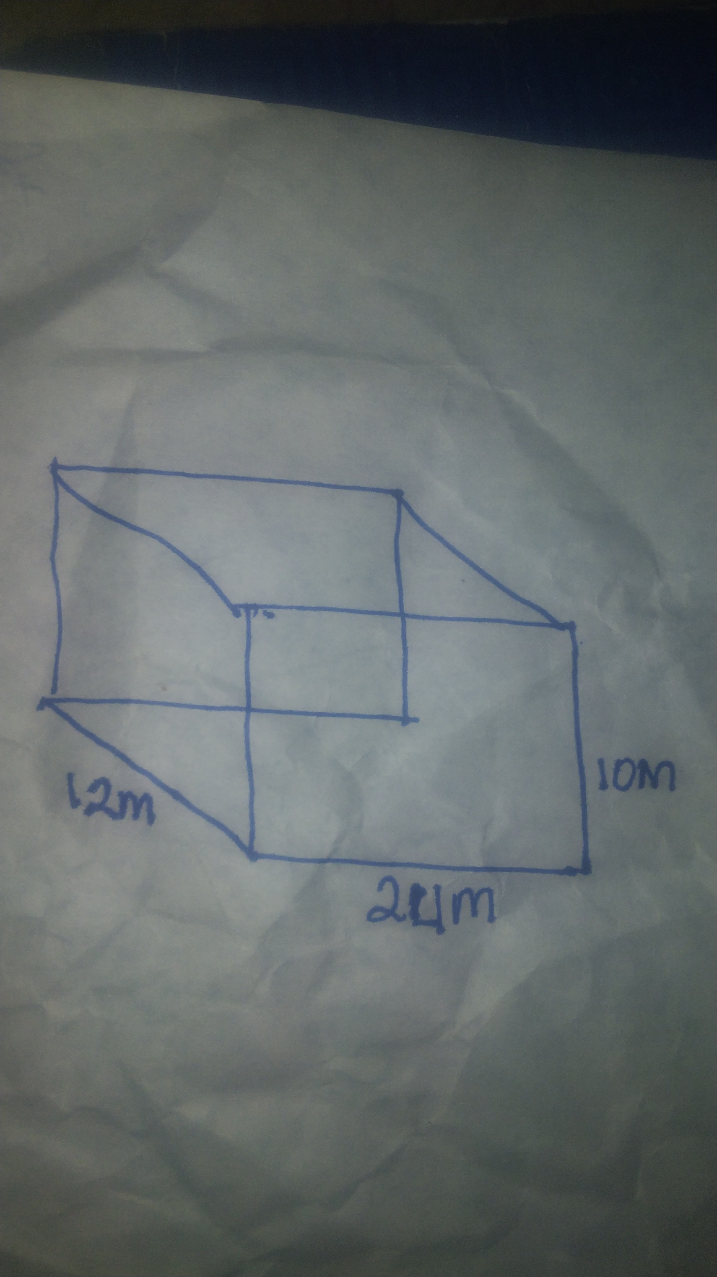

Calculate the maximum and minimum pressure the tank experts on the ground

1. An astronaut at the Nassa Astronomical Geosciences institute measured his weight while at the Institute and found out that it was 700N and when he moved to the moon and measured his weight ,he found out that it was 300N
2. Why do you think the weight changed when the astronaut moved to the moon
3. Calculate the mass of the astronaut while still at the institute ( use acceleration due to gravity g =10m/s²)

C) Calculate the acceleration due to gravity g at the moon

8 A ripe mango 🥭 fruit of mass 0.3kg falls freely from a tree 5m high and hits the ground

a) state the law which relates the energy changes that occur from the top of the treeto the ground

1. If the mango fruit fell from a short height of 2m it may not get damaged, why do you think the mango fruit does not get damaged when it falls from a short height
2. Calculate the kinetic energy of the mango fruit when it falls from a height of 5m

SECTION B

Answer any two questions

9 While at home waiting to wash your clothes you and your young sister saw an insect walking on top of water surface without sinking, Your sister wondered how this happened



1. Explain to your sister the type force which enables the insect to walk on water surface
2. Describe a simple laboratory experiment to demonstrate the existence of the force above
3. "When you boil water for washing clothes, the stains on the clothes becomes easy to remove "
4. Is the same statement in (C) above correct
5. Give reason to support your answer

10 Your sister has just graduated as a senior doctor and now you are going to the village for graduation ceremony, you have hired a taxi to take all the people who are to attend the ceremony their luggage as well as all utilities that you are to use while in the village,the taxi driver has loaded the car and now seems to be full yet more luggage is still there to be loaded,the taxi driver has now to load most of the luggage at the rack ( on top of the car)

Support material,

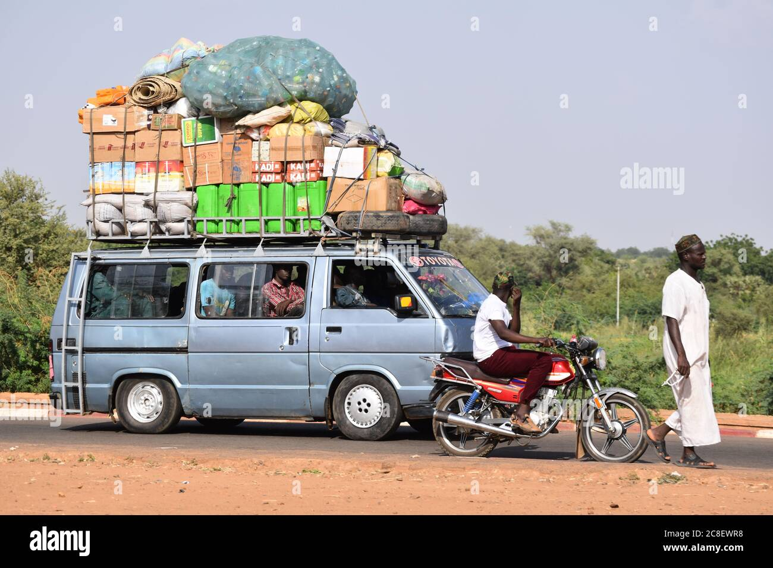

Task

Advice the taxi driver on how this kind of loading of a car can be of great danger to all of you on your way to the village

END